**Cross-Platform Web Design – CST8117 – Section 011**

**Style Guide**

Contenido

Client 2

Style 2

Platform 3

Semantic Design Guide 3

Website Map 5

# Description

Our team's goal is to make a full shopping simulation of an online shoes shop, users will be able to browse items through properly organized layout and catalog, register and login their account, add items to cart and make the purchase. Data will be most likely stored in local JavaScript for single-use purposes considering our lack of knowledge on backend and cookies.

**Font Style**

Font Family: **Open Sans**

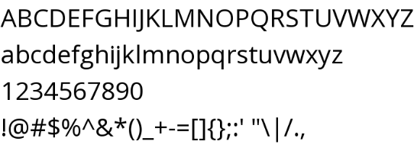

**Colors:**

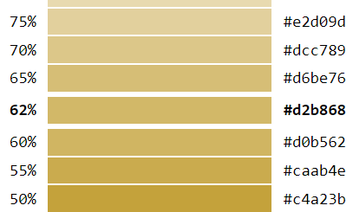

# Platform

The website will target traditional monitor resolutions of 1024X768 and greater and also surpporting screen size less than 500px width.

# Semantic Design Guide

**index.html**

* **loginCheck()**
* **cartCheck()**
* **getTrends()**

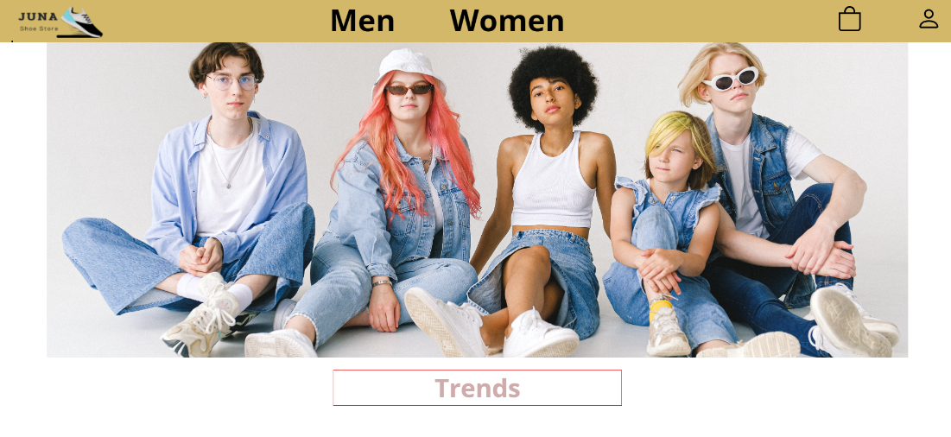

**List.html**

* **loginCheck()**
* **cartCheck()**
* **filterByBrand ()**
* **filterByType ()**

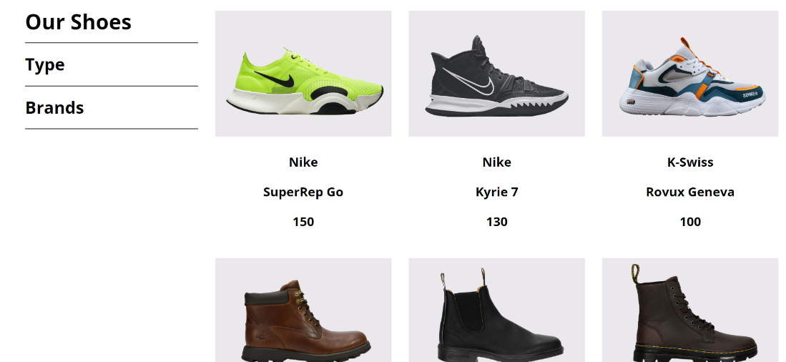

**login.html**

* **loginCheck()**
* **cartCheck()**
* **login()**
* **registración()**



**purchase.html**

* **purchase ()**
* **displayFinalCart()**

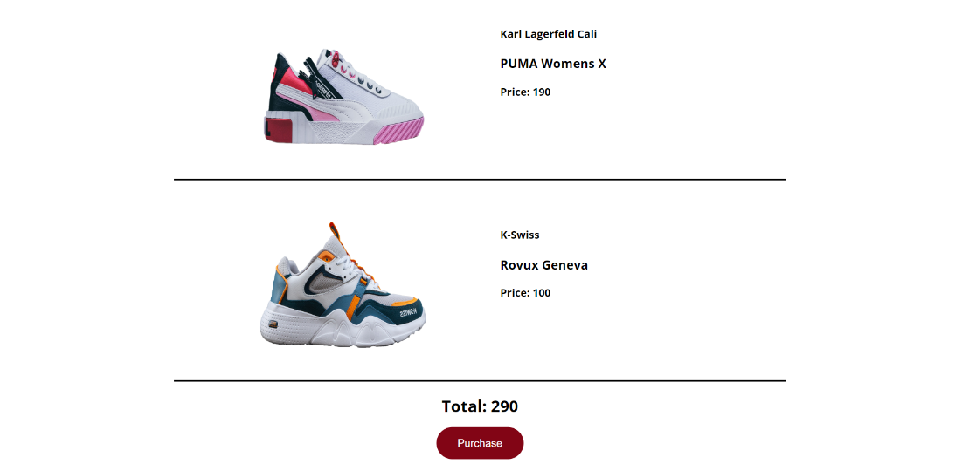

**Product.html**

* **loginCheck()**
* **cartCheck()**
* **displayCart()**
* **updateCart()**
* **closeCart()**
* **displayTotal()**
* **displayFinalCart()**